COCS345 Assignment Report

**What you are going to build?**

We are going to build a tile matching puzzle game called Advanced Tetris. In traditional Tetris games, Players will be able to rotate the Tetromino, cancel a line and get scores for cancelling lines. But in Advanced Tetris, we are also adding new features to the gameplay, such as new shapes of Tetris, new functions to help or challenge the player. If possible, we would also like to merge another 2D game into the Tetris gameplay. We want to make the players experience the differences from traditional Tetris games while playing Advanced Tetris.

**Who is going to build it?**

Our group members are:

Andrew Wang(6686467)

Ji Liu(2845570)

Bella Gao(3764478)

All members will participate in building and testing the project.

**How you are going to build it?**

For alpha version, we will build a smooth-running traditional Tetris game, ideally add some new features that are listed in below. play testing and debugging by group members apply on this stage.

For beta version, we will add more different features into the game, and may decide to trim off some inappropriate features depends on the line limit and feedback from other players outside our group. Play testing by players outside the group apply on this stage.

For final version, more play test and debugging apply to help smooth the game.

**How long it will take to build?**

We will use a Gantt chart to explain this section

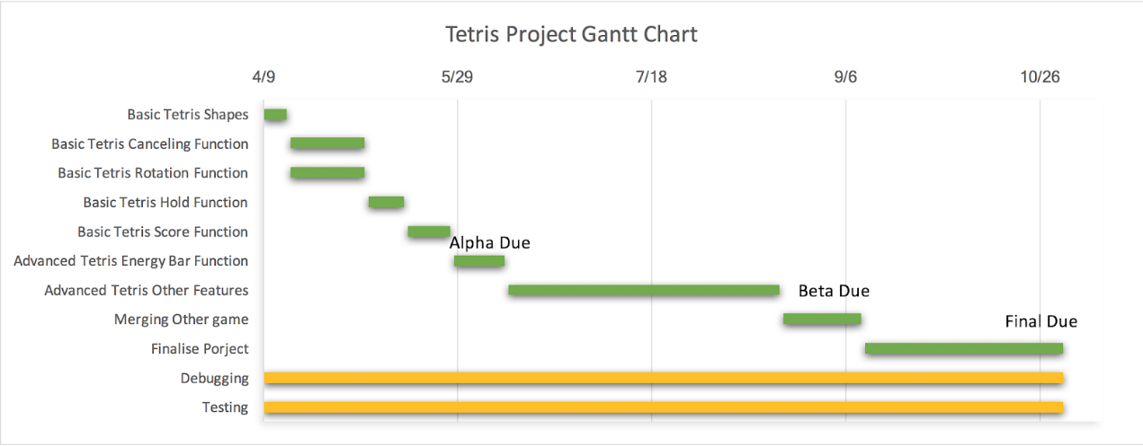

**Which standard layout you are going to use?**

K&R style, Variant 1TBS.

**What else there is that already does what your program will do?**

The traditional Tetris:

1. Has the same gravity for all shapes, gravity only changes through time

2. Colors are only used to distinguish a different shape which seems pretty obvious to players anyways.

3. Some Tetris has battle mode, that two players can battle through the game

4. Blocks can be rotated.

**How your program differs from those that do a similar task?**

Our Tetris:

1. Our Tetris is going to use different colors to represent different gravities, so that different gravities will act on the same shapes.
2. Our Tetris will have new shapes.
3. Our Tetris will gather energy if lines are cleared, once the energy are full filled, it will clear the entire screen.

Possible features(depends on if it can be done within 1000 lines):

1. Different ways to determine if game is completed other than traditional endless Tetris game.
2. Different rules to erase the line(such as leave the third block blank and fill the rest).
3. Merge another 2D game that has the same control mechanics as Tetris. (Something that also uses arrow keys).